# Bourbon Biscuit

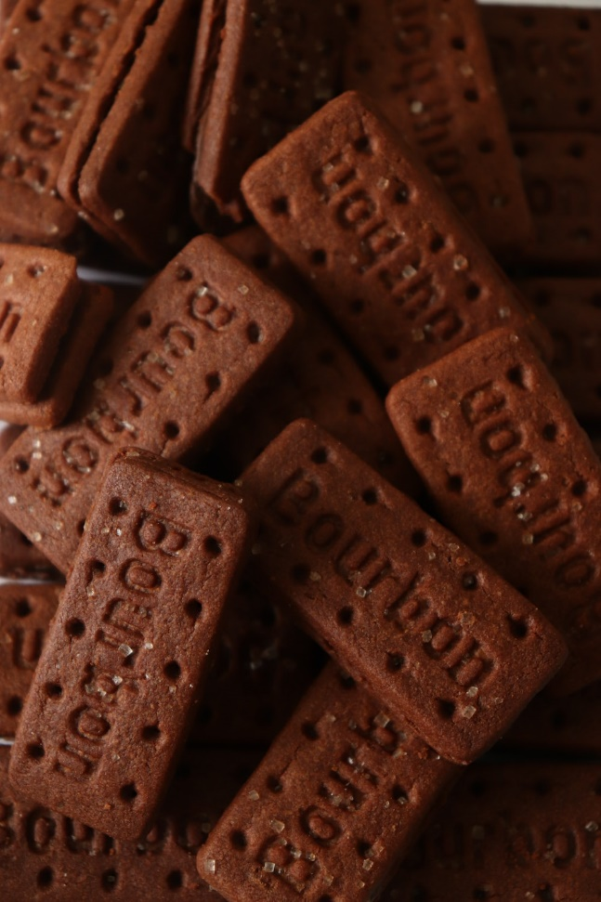

This all-chocolate sandwich biscuit was first introduced in 1910 by a company called Peek Freans. It consists of two rectangular dark chocolate biscuits with a chocolate buttercream filling, making it perfect for dunking on your hot beverage! In fact, according to a 2009 UK survey, it is the fifth most popular biscuit for dunking into tea. The basic ingredients to create this delicious treat are flour, sugar, oil, cocoa powder, salt and a raising agent. This biscuit is engineered with holes around it so that it does not break easily during the baking stage. And once finished, it creates a smooth finish with a crunchy bite! There are many biscuit companies that make their own version of Bourbon Biscuits, although they are all called the same. Fun fact: this biscuit was originally called “Creola” until the 1930s.